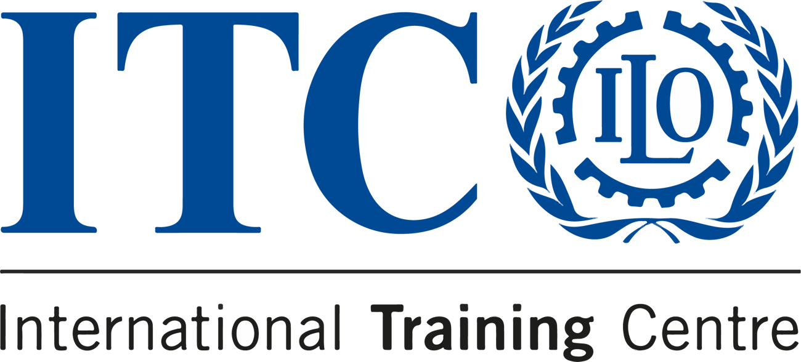

TESTIMONIALS
STORIES FROM OUR COMMUNICATION
FOR DEVELOPMENT COURSE

  DEADLINE  20 October 2023 |   LOCATION  Online |   LANGUAGE  English |  |   PRICE  €450

We believe in the transformative power of our Communication for Development course. But don’t take it from us - here are three real testimonials of the impact it has made.

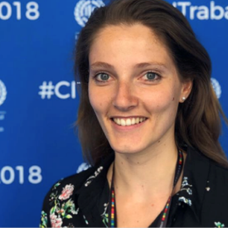 |  | Highly recommend the C4D course at ITCILO. I learned so much about innovation for social change and had so much fun building communication strategies from scratch with experts from all over the world.  — Marina Humblot  COMMUNICATION CONSULTANT, ILO

 |  | Grazie mille ITCILO for an interesting course that mainly refreshed my brain on comms and campaigns in particular. Ready to put this knowledge to use!  — Dimple Sokartara  COMMUNICATION MANAGER, EGI

 |  | Huge thanks to the ITCILO team for an expertly-crafted C4D programme full of hands-on experimentation and learning. For anyone interested in visual communications, storytelling or cross-cultural advocacy, I highly recommend this course.  — Claire Anholt  COMMUNICATION SPECIALIST, UN

Write your own success story!
Apply now

Do you know someone who'd love this course?
Tell them about it!
 |  |  | 

Sent to: crmsupport@itcilo.org
Unsubscribe
ITCILO, Viale Maestri del Lavoro 10, 10127 Turin, Italy

