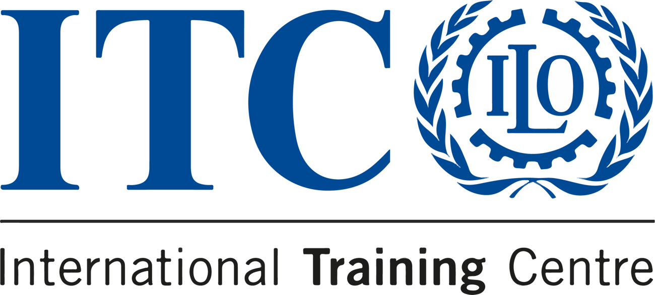

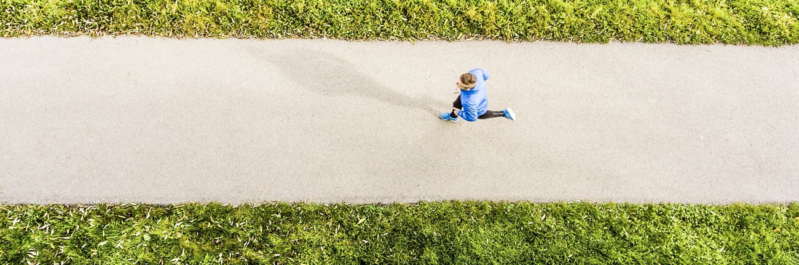
READY FOR A NEW YEAR OF TRAINING OPPORTUNITIES?
DISCOVER OUR 2024 DIPLOMA IN PUBLIC PROCUREMENT MANAGEMENT PROGRAMMES!

We are glad to inform you about the online Professional Procurement Certification Programmes taking place in 2024 and being part of our diploma.
The Diploma in Public Procurement Management for Sustainable Development is an initiative undertaken by the ITCILO to contribute to the reinforcing and upgrading capacity in the management of the procurement functions and operations at the institutional and operational levels.
The Diploma is composed of the five main online certification programmes offered by the ITCILO listed here below. For more information about course objectives and content, please click on the course title:
- Procurement Management for Goods and Physical Services
- Sustainable Public Procurement
- Procurement Management for Works
- Contracting and Managing Consultants
- Advanced Contract Management

Participants need to complete three of the five qualified courses of their choice within a 5-year period and complete a capstone project on the topic related to one of the two qualified courses they did not complete in order to earn the “Public Procurement Management” recognition through the diploma.
Please note that each course take place only ONCE during the 2024, please plan your learning accordingly.
For more information on the diploma please click here: https://www.itcilo.org/diplomas/diploma-public-procurement-management
For more information about all procurement courses please click here: https://www.itcilo.org/topics/procurement
Sincerely

Do you know someone who'd love this diploma?
Tell them about it!
Blerina Pogace Phd
Programme Officer
Development and Investment (DEVINVEST) Programme
devinvest@itcilo.org / itcilo_procurement@itcilo.org

International Training Centre of the ILO
Viale Maestri del Lavoro, 10 - 10127 Turin, Italy
Web www.itcilo.org
Get to know about our upcoming training offer
 |  |  | 

Sent to: s.amaiolo@itcilo.org
Unsubscribe
ITCILO, Viale Maestri del Lavoro 10, 10127 Turin, Italy

