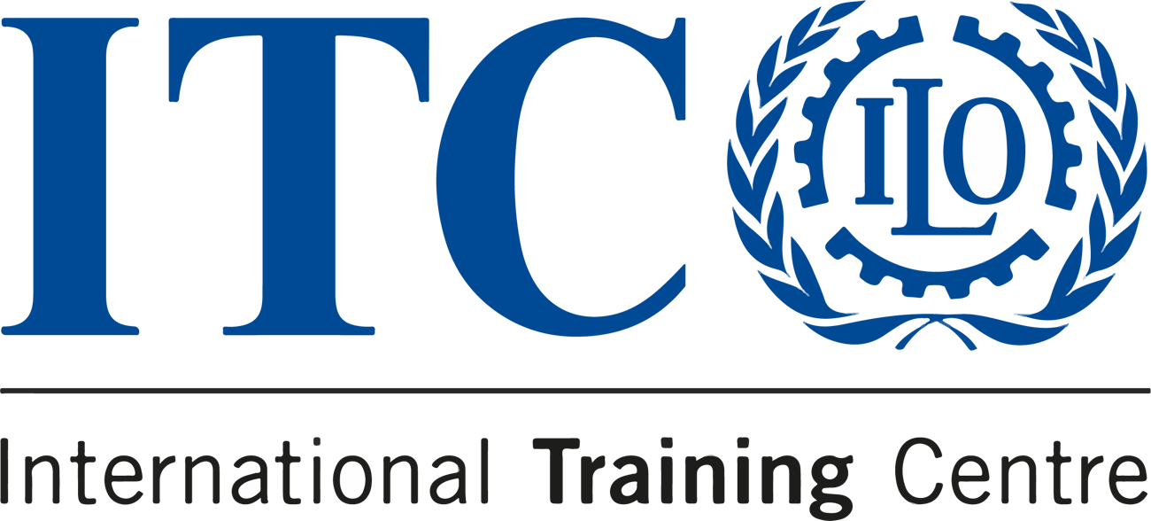

E-learning on Digital Transformation for Social Protection


  DEADLINE  29 Apr - 24 Jun |   APPLY BEFORE  15 April 2024 |   LANGUAGE  English |  |   PRICE  €1,025

Unlock the future of Social Protection: enrol in our course on
Digital Transformation for Social Protection
This online course is an opportunity to acquire the skills necessary
to lead social protection institutions through the digital age
Why should you join?

 |  | Learn from seasoned international experts: with decades of international experience in management, business strategy, innovation and social security.

Network with professionals from various backgrounds and organizations: the diversity of perspectives encourages out-of-the-box thinking and fosters innovative approaches.

Engage in interactive sessions, group exercises and case studies: This e-learning course consists of a blend of online resources and case studies, ‘real time’ interactive sessions, individual and collaborative group exercises using our E-Campus platform.

Earn an ITCILO Certificate of Achievement and move towards obtaining the ITCILO Diploma for Social Protection Managers: Successful participation to the course will grant you an official certification and the opportunity to take a further step in your learning journey.

JOIN US
Learn more and Apply

Not the course you were looking for?
Check out other courses eligible for the
Diploma for Social Protection Managers
Actuarial work for social security
Administrative solutions for extending coverage
Contribution, collection and compliance
Good governance
Information and communication technology
Investment of social security funds
Service quality
Advocacy and communication for social protection
Leadership for social protection
Academy on social security
Do you know someone who'd love this course?
Tell them about it
 |  |  | 

Sent to: s.amaiolo@itcilo.org
Unsubscribe
ITCILO, Viale Maestri del Lavoro 10, 10127 Turin, Italy

