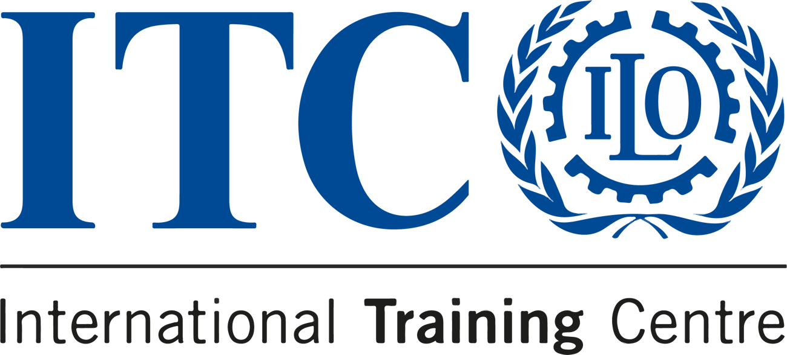


COURSE
COMMUNICATION FOR DEVELOPMENT

24 - 26 October 2023

  DEADLINE  20 October 2023 |   LOCATION  Face to Face |   LANGUAGE  English |  |   PRICE  €450

The transformative power of communication for development
Discover the transformative power of communication for development with our comprehensive course, designed for individuals passionate about driving real change.

We offer a practical and immersive learning experience over three days.
Delve into the strategic aspects of communication in the development sector, testing out the tools and skills needed to make a lasting impact. Our instructors, experts in the field, will not only share their knowledge but also facilitate a vibrant exchange of ideas.
Make positive changes through communication!
Learn more [link to ITC website]
Deadline of application is 15 August

Do you know someone who'd love this course?
Tell them about it!
 |  |  | 

Sent to: s.amaiolo@itcilo.org
Unsubscribe
ITCILO, Viale Maestri del Lavoro 10, 10127 Turin, Italy

