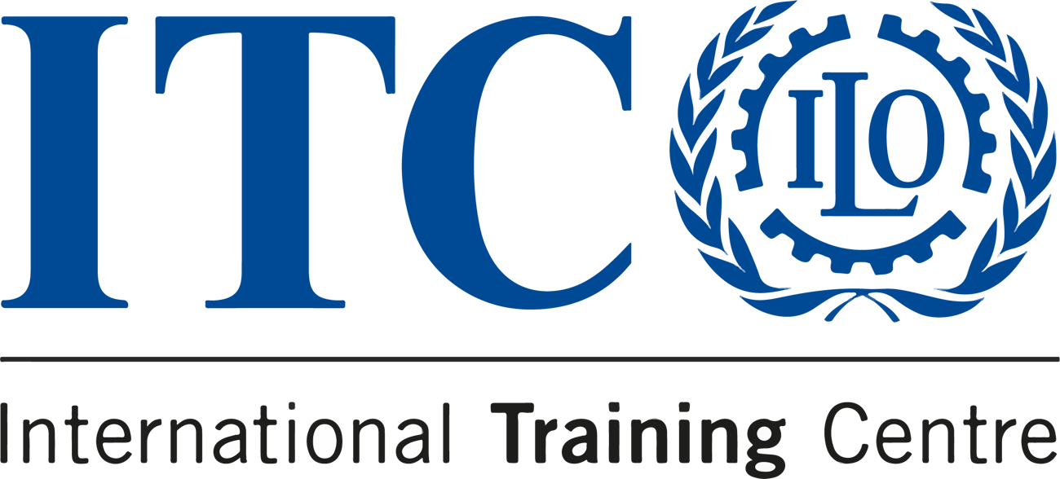



LAST CALL TO JOIN THE BLENDED COURSE
ACCESS TO DECENT WORK FOR REFUGEES AND OTHER FORCIBLY DISPLACED PERSONS

  DATES  Online (eCampus):  1-21 April 2024  Turin, Italy: 22-26 April 2024  Online (eCampus):  27 April - 3 May 2024 |   LANGUAGE  English |  |   APPLICATION DEADLINE  25 February 2024

REGISTRATION DEADLINE APPROACHING!

According to the latest available global estimates, more than 110 million people are displaced by persecution, conflict, violence, and widespread human rights violations, especially in emerging economies. The ever-changing nature of forced displacement has wider socio-economic repercussions and implications, and global debates are still grappling with the challenge of how to develop appropriate and sustainable policy responses.

If you want to learn how to design and implement measures that facilitate the access of refugees and other forcibly displaced persons to the labour market, you need look no further:

After a successful 2023 edition, the ITCILO course on Access to Decent Work for Refugees and Other Forcibly Displaced Persons returns in 2024, redesigned in blended format to seamlessly combine online learning with face-to-face workshops.

Key Objectives:
- Understanding the impact of refugees and other forcibly displaced persons on labour markets
- Exploring how human rights law and international labour standards provide decent work and social protection
- Advocating for the importance of including host communities in new strategies for employment creation in the formal labour market.
- Accessing tools and methodologies to address the labour market impacts and promote employment-based responses to refugee situations.

What Sets Us Apart:
- Based on the 2016 ILO Guiding Principles on the access of refugees and other forcibly displaced persons to the labour market, ILO standards, human-rights instruments and good practices, our course offers a comprehensive curriculum.
- Expert facilitators guide you through engaging lectures and innovative exercises.
- Flexible learning on our e-Campus platform and in-person at our Turin campus.
- Opportunities to exchange knowledge and ideas with global practitioners.
- Qualifies for the ITCILO Diploma for Labour Migration Experts and Practitioners.

How to Join:
Are you a policymaker or practitioner looking for inclusive strategies and approaches to facilitate access to decent work for refugees and forcibly displaced populations? Then seize this opportunity and join us for this new edition.
GET READY
Join us in paving the way for fair, effective, and coherent labour migration policies!
For further details, contact migration@itcilo.org.
Apply now
Apply before 25 February 2024 to secure your place!

Do you know someone who'd love this course?
Tell them about it!
 |  |  | 

Copyright © 2024 International Training Centre of the ILO, All rights reserved.

Sent to: crmsupport@itcilo.org
Unsubscribe
ITCILO, Viale Maestri del Lavoro 10, 10127 Turin, Italy

