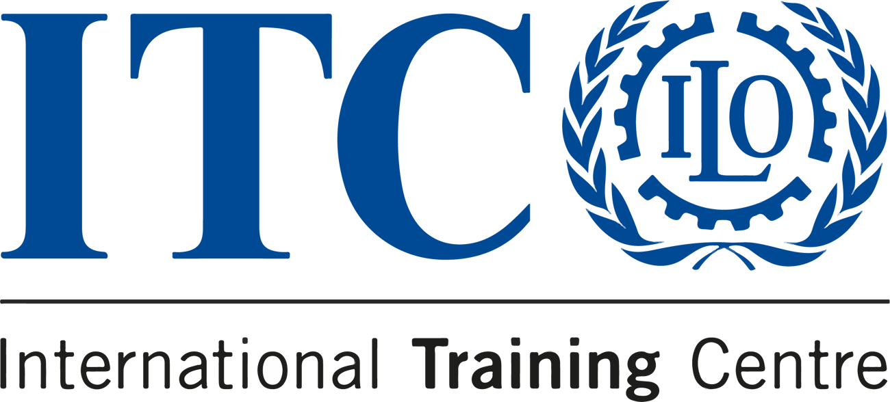

ELEVATE YOUR SKILLS IN
COMMUNICATION FOR DEVELOPMENT!


  DEADLINE  20 October 2023 |   LOCATION  Online |   LANGUAGE  English |  |   PRICE  €450

Are you searching for a course that not only enriches your knowledge
but empowers you to drive real change?
Our Communication for Development course is the perfect opportunity to elevate your skills and make a profound impact in the development sector.
Why should you join?

 |  | Tailored learning streams: One size does not fit all. We offer specialized learning streams, allowing you to focus on what truly interests you. You can customize your learning experience to match your passions and goals.

Diverse and inspiring expertise: Our course is designed and delivered by leading experts in the field of communication for development. The diversity of perspectives encourages out-of-the-box thinking and fosters innovative approaches.

Hands-on experience: Our course structure emphasizes practical application.
We provide a full day of practical workshops where you can put your newly-acquired skills to the test.

JOIN US
Apply now

Do you know someone who'd love this course?
Tell them about it!
 |  |  | 

Sent to: crmsupport@itcilo.org
Unsubscribe
ITCILO, Viale Maestri del Lavoro 10, 10127 Turin, Italy

