

Dear Sir or Madam,
We are pleased to inform you that the International Training Centre of the ILO is organizing the following courses in the field of Occupational Safety and Health and Labour Inspection for 2024. The training courses outlined below will be offered in English. For the training offer in other languages please do not hesitate to contact our team.
We would be most grateful if you could disseminate this information among interested individuals, partners and organizations. We also remain available for any additional information or clarification you may need.
Looking forward to welcoming you at our training activities!

Our courses include:

  DATES: 15 April–14 June 2024  LOCATION: Online (E-Campus)  LANGUAGE:English  DEADLINE: 22 March 2024 |  | IMPROVING THE NATIONAL FRAMEWORK FOR OCCUPATIONAL SAFETY AND HEALTH (NEW)  In June 2022, the International Labour Conference at its 110th Session adopted the resolution on the inclusion of a "safe and healthy working environment" in the ILO's framework of fundamental principles and rights at work. The fundamental Conventions on occupational safety and health, Convention No. 155 and...

Learn more and apply

  DATES: 22 April–28 June 2024  LOCATION:BLENDED  Online: 22 April – 14 June 2024  Turin, Italy: 17 – 28 June 2024  LANGUAGE:English  DEADLINE: 31 March 2024 |  | EMPLOYMENT INJURY SCHEMES AND THE PREVENTION OF OCCUPATIONAL ACCIDENTS AND DISEASES  Employment injury schemes are part of the social security branch in charge of the workers' insurance for occupational accidents and diseases. Traditionally, they provide for compensation and coverage of the medical and rehabilitation costs of the injured and sick workers. Increasingly, the prevention of the occupational risks is becoming part of the mandate of these schemes and...

Learn more and apply

  DATES: 6 May–28 June 2024  LOCATION: Online (E-Campus)  LANGUAGE:English, French  DEADLINE: 19 April 2024 |  | E-LEARNING COURSE ON LABOUR INSPECTION  The course will familiarize participants with the principles, functions and main characteristics of labour inspection. Participants will be able to choose from different compliance strategies and carry out a comprehensive and effective labour inspection visit relating to working conditions and occupational safety and health...

Learn more and apply

  DATES: 20–24 May 2024  LOCATION: FACE-TO-FACE, Turin, Italy  LANGUAGE:English  DEADLINE: 12 April 2024 |  | ILO CODE OF PRACTICE ON OCCUPATIONAL SAFETY AND HEALTH IN THE TEXTILES, CLOTHING, LEATHER AND FOOTWEAR INDUSTRIES  In October 2021, a meeting of experts adopted the first ILO code of practice on safety and health in textiles, clothing, leather and footwear industries. Based on international labour standards and other sectoral guidelines and tools, the...

Learn more and apply

DATES: 1 July–23 August 2024  LOCATION: Online (E-Campus)  LANGUAGE:English, Spanish  DEADLINE: 7 June 2024 |  | E-LEARNING COURSE ON LABOUR INSPECTION  The course will familiarize participants with the principles, functions and main characteristics of labour inspection. Participants will be able to choose from different compliance strategies and carry out a comprehensive and effective labour inspection visit relating to working conditions and occupational safety and health...

Learn more and apply

  DATES: 26–30 August 2024  LOCATION: FACE-TO-FACE, Turin, Italy  LANGUAGE:English  DEADLINE: 12 July 2024 |  | SOCIAL SECURITY INSPECTION (NEW)  The course will provide the participants with a panorama of current approaches to the social security inspection as well as the most relevant tools, resources and strategies. The course is built around the interaction between social security, occupational safety and labour inspection. Participants will have an opportunity to explore practical issues surrounding the preparation...

Learn more and apply

  DATES:26 August–6 September 2024  LOCATION: FACE-TO-FACE, Turin, Italy  LANGUAGE:English  DEADLINE:12 July 2024 |  | TRAINING OF TRAINERS ON BUILDING MODERN AND EFFECTIVE LABOUR INSPECTION SYSTEMS  LABADMIN/OSH (the ILO department in charge of Labour Administration, Labour Inspection and Occupational Safety and Health), has developed a training curriculum for raising the level of competence of labour inspectorates. The curriculum, named "Building Modern and Effective Labour...

Learn more and apply

  DATES: 9 September 2024–17 January 2025  LOCATION:Online (E-Campus)  LANGUAGE:English, Spanish  DEADLINE: 16 August 2024 |  | DISTANCE LEARNING COURSE ON OCCUPATIONAL SAFETY AND HEALTH (ENGLISH, SPANISH)  Becoming a safety and health professional requires multidisciplinary training. The OSH profession calls for a broad-based educational background combined with specialized knowledge of physical sciences (medicine, physics, chemistry and engineering), social sciences...

Learn more and apply

  DATES:9 September 2024–30 September 2025  LOCATION:BLENDED  Online: 9 September 2024 – 19 January 2025  Turin, Italy: 20 January – 4 April 2025  Online: 5 April – 30 September 2025  LANGUAGE:English  DEADLINE: 31 May 2024 |  | MASTER IN OCCUPATIONAL SAFETY AND HEALTH  OSH professionals need a multidisciplinary background to successfully operate in the broad field of OSH, therefore the programme incorporates training sessions on all of the topics and disciplines relevant to OSH. The University of Turin, Italy, in partnership with the International Training Centre of the International Labour Organization (ITCILO), is offering a Master course in Occupational Safety and Health...

Learn more and apply

  DATES:23 September-15 November 2024  LOCATION:Online (E-Campus)  LANGUAGE:English  DEADLINE:30 August 2024 |  | E-LEARNING COURSE ON LABOUR INSPECTION (ADVANCED) (NEW)  The course is designed to provide an in-depth understanding of the role of labour inspectors in ensuring compliance with national labour law. Participants will be able to examine the key considerations for efficient labour inspection policy, including a coherent institutional capacity...

Learn more and apply

  DATES:21 October-1 November 2024  LOCATION: FACE-TO-FACE, Turin, Italy  LANGUAGE:English  DEADLINE:6 September 2024 |  | THE PREVENTION OF WORK-RELATED OCCUPATIONAL DISEASES  Preventing the occurrence of occupational diseases requires knowing and anticipating the health hazards to the workers that may arise from the work processes, operations and equipment in a company, in order to eliminate these hazards or plan other appropriate interventions to control risks to the health. This means...

Learn more and apply

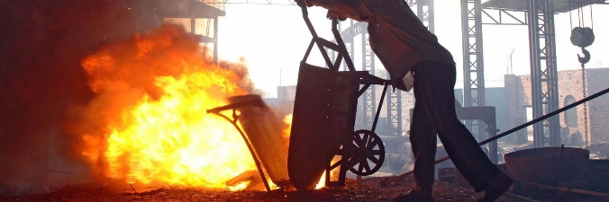  DATES:18-21 November 2024  LOCATION:Online (E-Campus)  LANGUAGE:English  DEADLINE:31 October 2024 |  | ONLINE WORKSHOP ON ILO INTERNATIONAL CLASSIFICATION OF RADIOGRAPHS OF PNEUMOCONIOSES (NEW)  The prevention of occupational respiratory diseases has a high priority in the ILO. Despite all international and national efforts to prevent them, they continue to be the leading occupational illnesses in many countries that may amount to as many as 30% of all registered work-related diseases. Pneumoconiosis cause significant numbers of cases of disabilities....

Learn more and apply

  DATES:25-29 November 2024  LOCATION:FACE-TO-FACE, Turin, Italy  LANGUAGE:English  DEADLINE:11 October 2024 |  | WORKSHOP ON MANAGEMENT OF OCCUPATIONAL SAFETY AND HEALTH IN INTERNATIONAL ORGANIZATIONS OF THE UNITED NATIONS  International organizations face the challenge of managing Occupational Safety and Health (OSH). Frequently, the nature of their operations, the legal frameworks of reference or the lack of an integrated approach has resulted on unsatisfactory management systems for the...

Learn more and apply

FREE COURSES ARE SELF-PACED AND AVAILABLE AT ANY TIME:
Our free courses include:

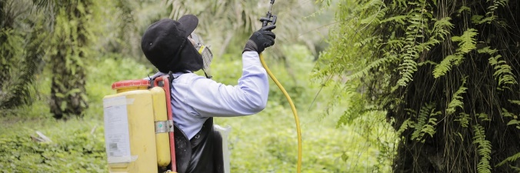  FREE  DATES: Any time, self-paced  LANGUAGE:English, Spanish  LOCATION: Online |  | MANAGEMENT OF THE CHEMICAL RISK IN THE AGRICULTURAL SECTOR  Risk management associated with the use of chemical substances in the workplace has gained great relevance from international and national regulations and from the interest of people and companies for protection against the potential effects of chemical substances. For this reason, the ILO with the cooperation of the European Union has developed...

Learn more and apply

  FREE  DATES: Any time, self-paced  LANGUAGE:English, Spanish  LOCATION: Online |  | IMPROVING WORKING AND HEALTH CONDITIONS IN AGRICULTURE  This course is an online adaptation of the ILO training program "Work Improvement in Neighbourhood Development" or WIND. The WIND program consists of conducting training workshops with a participatory, action-oriented methodology to improve working and health conditions in work and living environments. The ILO Vision Zero Fund, thanks to...

Learn more and apply

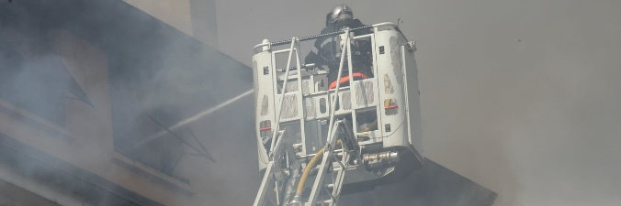  FREE  DATES: Any time, self-paced  LANGUAGE:English  LOCATION: Online |  | MAJOR INDUSTRIAL ACCIDENTS AND THEIR PREVENTION  This course is an online adaptation of the ILO training package on the Major Industrial Accidents and their Prevention. It promotes the ILO International Labour Standards and other instruments for the Prevention of Major Industrial Accidents as well as other selected good practices at the national and at the workplace level. This course was developed...

Learn more and apply

  FREE  DATES: Any time, self-paced  LANGUAGE:English, Bengali  LOCATION: Online |  | ESSENTIALS OF FIRE SAFETY INSPECTION  The underlying message in this initiative is to ensure that sustainable mechanisms are in place to prevent future tragedies and ensure safe working conditions. Much has been accomplished in this effort. The three initiatives of the National Tripartite Committee, The ACCORD, and the Alliance are working diligently to complete pre-assessment on time and move immediately into the remediation...

Learn more and apply

  FREE  DATES: Any time, self-paced  LANGUAGE:English  LOCATION: Online |  | FIRE SAFETY MANAGEMENT  Each year in every country around the world there are serious fire incidents and people will die or seriously injured due to the fire or resulting smoke. A contributing factor will be the inability to find safe passage to exit the building. The best approach to fire safety is to prevent fires in the first place. Proactive fire safety management helps to achieve this. When these incidents occur, protected escape routes...

Learn more and apply

Do you know someone who'd love to know about these courses?
Spread the word!
Social Protection, Governance and Tripartism Programme
International Training Centre of the ILO
Viale Maestri del Lavoro, 10 10127 Turin (Italy)

Mr. Félix Martín Daza  Tel. +39 011 6936576  E-mail. F.Martin@itcilo.org | Mr. Munehisa Uematsu  Tel. +39 011 6936930  E-mail. M.Uematsu@itcilo.org |  | Ms. Olena Vazhynska  Tel. +39 011 6936958  E-mail. O.Vazhynska@itcilo.org  LinkedIn

Learn more about our courses on Occupational Safety and Health and Labour Inspection
 |  |  | 

Copyright © 2024 International Training Centre of the ILO, All rights reserved.

Sent to: s.amaiolo@itcilo.org
Unsubscribe
ITCILO, Viale Maestri del Lavoro 10, 10127 Turin, Italy

