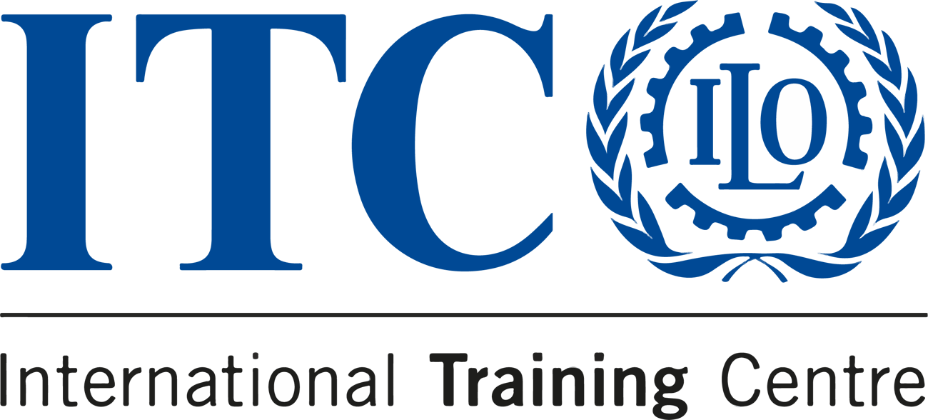

Stories from our Communication for Development Course
COURSE
COMMUNICATION FOR DEVELOPMENT

Online: 20 - 23 October 2023
Turin, Italy: 24 - 26 October 2023

  
  DEADLINE
  20 October 2023
  
  LOCATION
  Online & Turin
  
  LOCATION
  English
  
  PRICE
  €450

We believe in the transformative power of our Communication for Development course. But don’t take it from us - here are three real testimonials of the impact it has made.

  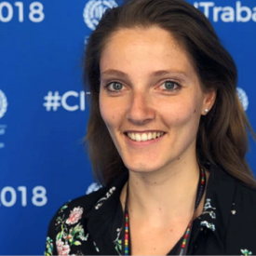
  Highly recommend the C4D course at ITCILO. I learned so much about innovation for social change and had so much fun building communication strategies from scratch with experts from all over the world.
  — Marina Humblot
  COMMUNICATION CONSULTANT, ILO

  
  Grazie mille ITCILO for an interesting course that mainly refreshed my brain on comms and campaigns in particular. Ready to put this knowledge to use!
  — Dimple Sokartara
  COMMUNICATION MANAGER, EGI

  
  Huge thanks to the ITCILO team for an expertly-crafted C4D programme full of hands-on experimentation and learning. For anyone interested in visual communications, storytelling or cross-cultural advocacy, I highly recommend this course.
  — Claire Anholt
  COMMUNICATION SPECIALIST, UN

Write your own success story!
Apply now
Application deadline 15 August

Do you know someone who'd love this course?
Tell them about it!
 |  |  | 

