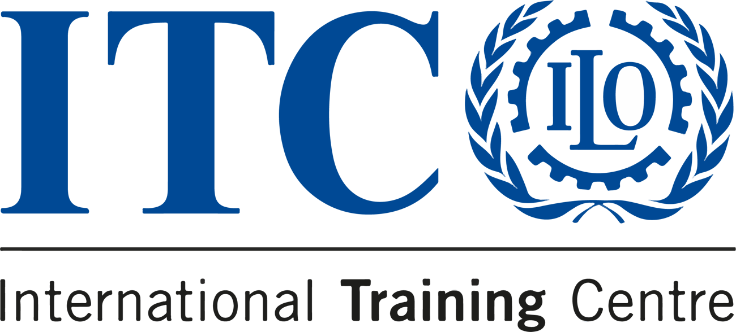

Last spots available for the Communication for Development course


COURSE
COMMUNICATION FOR DEVELOPMENT

Online: 20 - 23 October 2023
Turin, Italy: 24 - 26 October 2023

  
  DEADLINE
  20 October 2023
  
  LOCATION
  Online
  
  LANGUAGE
  English
  
  PRICE
  €450

This is your final chance to embark on a journey of learning with our Communication for Development course in 2023
Our course is a unique opportunity to explore the strategic aspects of communication in development, guided by leading experts in the field. You’ll immerse yourself in practical workshops, diverse learning streams, and hands-on experiences that
will empower you to drive real change.

Apply now
Apply before 7 October to secure your place!

Do you know someone who'd love this course?
Tell them about it!
 |  |  | 

