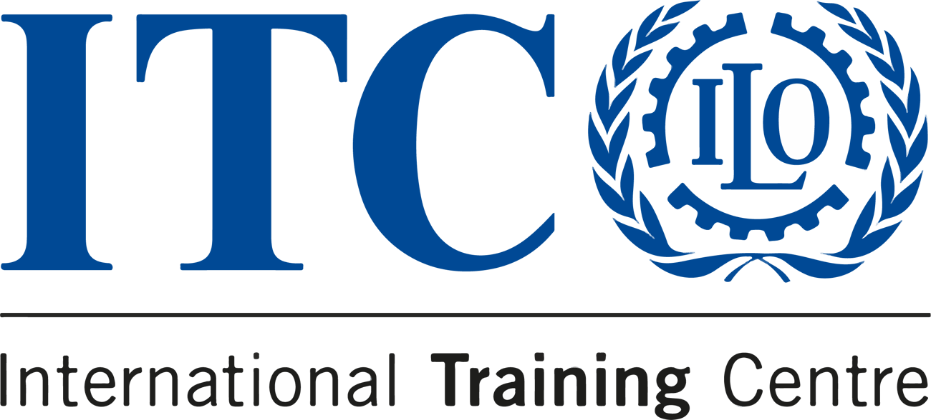


COURSE
COMMUNICATION FOR DEVELOPMENT
This is your final chance to embark on a journey of transformative learning with our Communication for Development course in 2023!

  
  DEADLINE
  20 October 2023
  
  LOCATION
  Online
  
  LANGUAGE
  English
  
  PRICE
  €450

Here’s a quick recap of what you can expect:
Our course is a unique opportunity to explore the strategic aspects of communication in development, guided by leading experts in the field. You’ll immerse yourself in practical workshops, diverse learning streams, and hands-on experiences that
will empower you to drive real change.
Apply now
Apply before 7 October to secure your place!

Do you know someone who'd love this course?
Tell them about it!
 |  |  | 

Sent to: s.amaiolo@itcilo.org
Unsubscribe
ITCILO, Viale Maestri del Lavoro 10, 10127 Turin, Italy

