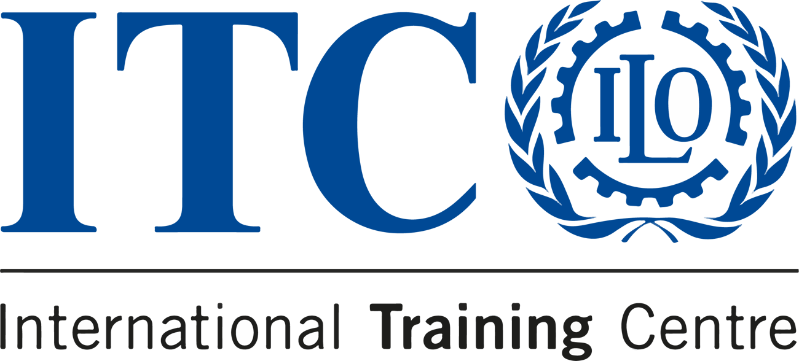

DISCOVER OUR 2024
MANAGEMENT COURSES!

The Organizational Development and Project Services Programme offers training to promote concrete action for economic, social, and environmental sustainability!
Greetings for the New Year! I hope this message finds you well.

I am writing to introduce you to our expanded range of training programmes for 2024 at the International Training Centre of the International Labour Organization (ITCILO). This year, we're focusing on broadening our initiatives in organizational development. Our offerings include organizational diagnostics, change management, facilitation of team-building retreats, leadership programmes, training of trainers, project document writing, and the establishment of monitoring and evaluation systems. Additionally, we are enhancing our courses and services in data-driven solutions, knowledge management services, and digital transformation projects.

A key focus for 2024 remains our commitment to e-learning, strengthened by our personalized online coaching approach and our aim to minimize the carbon footprint of training activities. Our innovative online learning framework is tailored to provide a comprehensive experience, combining self-learning, peer learning, expert teaching, and coaching, all contextualized for the professional development of participants.

Enclosed is a list of our certification programmes for the first half of 2024, which includes both online and face-to-face sessions at the ITCILO campus. These programmes cover areas of Programme and Project Cycle Management and Organisational Development.
Online on ITCILO ecampus

  
  Evaluation Fundamentals
  DATES: 26 FEBRUARY–11 APRIL 2024
  PLACE: Online
  PRICE: 1,050€

  
  Project Design
  DATES: 4 MARCH–10 MAY 2024
  PLACE: Online
  PRICE: 1,050€

  
  Monitoring and Evaluation
  DATES: 18 MARCH–10 MAY 2024
  PLACE: Online
  PRICE: 1,050€

  
  Financial Management for Development Professionals
  DATES: 8 APRIL–31 MAY 2024
  PLACE: Online
  PRICE: 1,050€

  
  Data Analytics and Knowledge Management for Development
  DATES: 29 APRIL–21 JUNE 2024
  PLACE: Online
  PRICE: 1,050€

  
  Impact Evaluation of policies, programmes and projects
  DATES: 29 APRIL–21 JUNE 2024
  PLACE: Online
  PRICE: 1,050€

  
  Effective Project Management
  DATES: 6 MAY–28 JUNE 2024
  PLACE: Online
  PRICE: 1,050€

  
  Organisational Development and Change Management
  DATES: 6 MAY–28 JUNE 2024
  PLACE: Online
  PRICE: 1,050€

Campus-based in Turin, Italy

  
  Leadership Skills: making team effective
  DATES: 05 JUNE- 28 JULY 2024
  PLACE: Online and in Turin, Italy
  PRICE: 2,575€

Effective Project Management
DATES: 17 JUNE – 9 AUGUST 2024
PLACE: Online and in Turin, Italy
PRICE: 2,575€

Financial Management for Development Projects
DATES: 17 JUNE – 9 AUGUST 2024
PLACE: Online and in Turin, Italy
PRICE: 2,575€

Impact Evaluation of policies, programmes and projects
DATES: 17 JUNE – 9 AUGUST 2024
PLACE: Online and in Turin, Italy
PRICE: 2,575€

Monitoring and Evaluation
DATES: 17 JUNE – 9 AUGUST 2024
PLACE: Online and in Turin, Italy
PRICE: 2,575€

Project Design
DATES: 17 JUNE – 9 AUGUST 2024
PLACE: Online and in Turin, Italy
PRICE: 2,575€

The complete list of ODPS short professional courses for the year 2024 is available here or simply email us at odps@itcilo.org for further information about our organizational services.

We would appreciate it if you could share the link among the staff of your organization that may be interested in some of these training opportunities.

Hoping that this information is useful for you and your colleagues, I send my best regards,

Guillaume Mercier
Programme Manager
The Organizational Development and Project Services Programme (ODPS)
JOIN US
Be part of the change!
Browse ODPS catalogue

Do you know someone who'd love to know about these courses?
Spread the word!
Organizational Development and Project Services Programme (ODPS)
International Training Centre of the ILO
Viale Maestri del Lavoro, 10 - 10127 Turin, Italy
Web www.itcilo.org
Get to know about our upcoming training offer
 |  |  | 

Copyright © 2024 International Training Centre of the ILO, All rights reserved.

Sent to: s.amaiolo@itcilo.org
Unsubscribe
ITCILO, Viale Maestri del Lavoro 10, 10127 Turin, Italy

