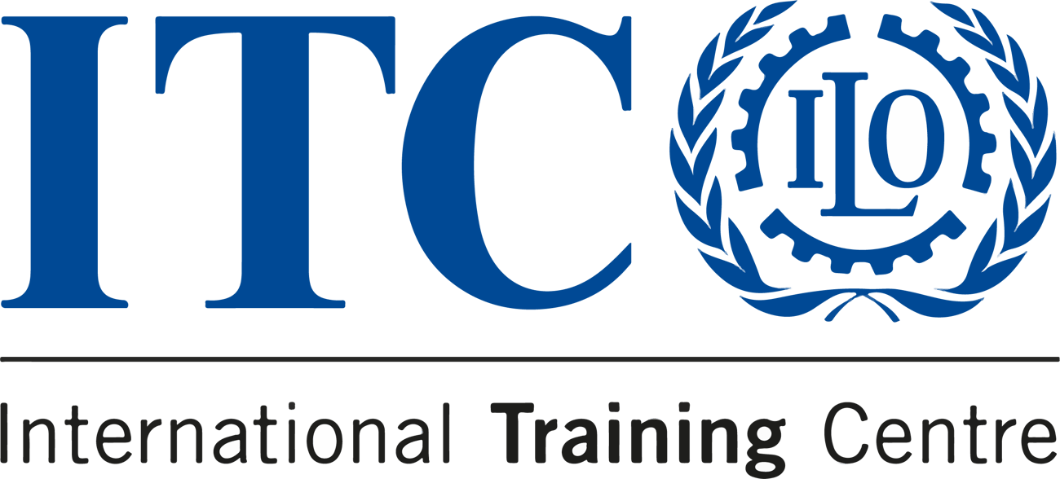

2025 COMPASS NEWSLETTER

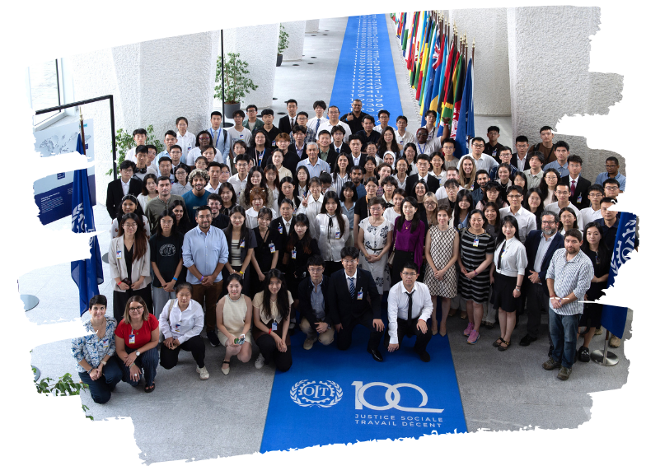

Dear Alumni,
Wishing you a joyful holiday season filled with warmth and love! Thank you for your achievements and contributions this year. Here’s to a bright and impactful 2025 together!

New DEVINVEST Programme Intern:
Mr. Menghao WEI
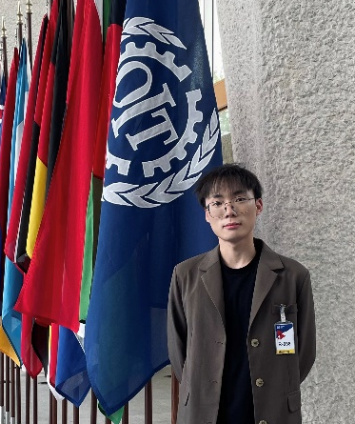

A Master of Laws student from Xi’an Jiaotong University,
Menghao successfully completed the 2024 edition of Future Leaders
in the World of Work. He is the first to join the programme live at the
United Nations Turin Campus, where he’ll support activities and
events designed for aspiring international civil servants.
Let’s welcome him at guest.wei@itcilo.org!

Join the Global Youth Forum 2025!
The ITCILO Global Youth Forum is an online learning event
empowering youth to design sustainable solutions grounded
in SDG 8 for economic growth and decent work.
Apply now—deadline approaching!
Secure your spot by January 20, 2025
https://www.itcilo.org/courses/global-youth-forum-2025
2 Scholarships Available
Enter the ILO Youth Employment Barometer Survey Prize Draw
By completing the #YouthEmploymentBarometer survey, you’ll
enter the ILO prize draw for a chance to win scholarships,
e-learning subscriptions & blog publication opportunities!
Take the survey:
https://bit.ly/YEB | More info: https://bit.ly/YEBi

What is INTEGRŌ?

INTEGRŌ is the global competency development facility for future leaders in the world of work of the International Training Centre of the International Labour Organization (ITCILO) – a portfolio of training activities for the next generation of mission-driven leaders with an ambition to shape international organizations, the social and solidarity economy, and the private sector.

Any new opportunity you'd like to see featured?

Let us know by dropping us a line at integro@itcilo.org

International Training Centre of the ILO
Development and Investment Programme (DEVINVEST)
Viale Maestri del Lavoro, 10 10127



Turin – Italy


