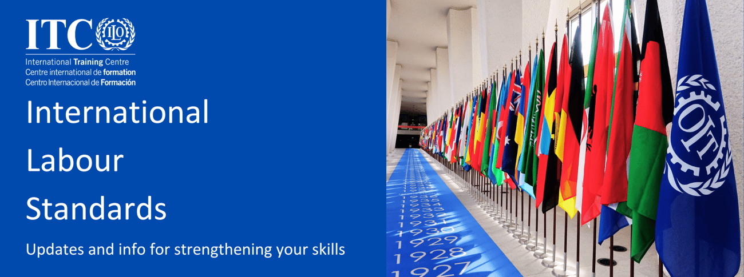

We are glad to share with you updates about new resources and information about upcoming training activities on International Labour Standards (ILS).
New reports

  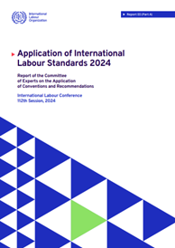
  2024 Report of the Committee of Experts on the Application of Conventions and Recommendations
  Report III(A) – For discussion at the 112th Session of the ILC in 2024
  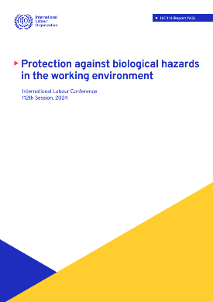
  Protection against biological hazards in the working environment
  Report IV(2) – Yellow report for discussion at the 112th Session of the ILC in 2024

  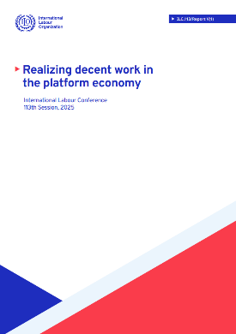
  Realizing decent work in the platform economy
  Report V(1) – White report containing a questionnaire, which must reach the Office no later than 31 August 2024
  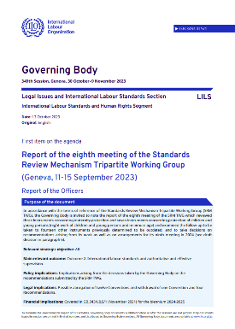
  Report of the eighth meeting of the Standards Review Mechanism Tripartite Working Group
  GB.349/LILS/1 – Discussed at the November 2023 Governing Body

  FREE RESOURCE
  Recording of the global webinar on employment injury protection
  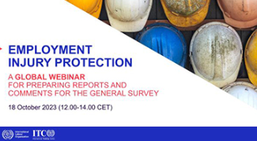
  The recording of the global webinar for preparing reports and comments for the General Survey on employment injury protection instruments, to be prepared by the Committee of Experts on the Application of Conventions and Recommendations in 2024, and to be discussed by the Conference Committee on the Application of Standards in 2025 is still available on the ILO website. In addition to English, the recording is also available in French, Spanish, Arabic, Portuguese and Russian.
  Watch the recording

Upcoming courses
Do you want to participate fully in all stages of the ILO’s normative cycle?
Do you want to effectively contribute to standards-related consultations nationally?
Do you want to prepare reports on the application of ILS that include exhaustive information and respond to the comments made by the ILO supervisory bodies?

  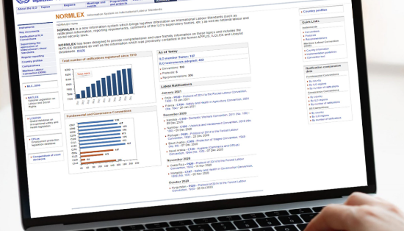
  Best practices in international labour standards reporting
  18 March – 26 April 2024
  What? This tutor-based training provides knowledge and skills for improving reports on ratified Conventions.
  How? Self-guided sessions, with interactive materials to work with and quizzes, combined with live webinars and ecoaching sessions.
  How many learning hours each week? Approximately 6 hours.
  LEARN MORE AND APPLY
  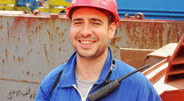
  Reporting on the Maritime Labour Convention, 2006
  18 March – 10 May 2024
  What? This tutor-based training provides knowledge and skills for improving reports on the application of the MLC, 2006, by ratifying States.
  How? Self-guided sessions, with interactive materials to work with and quizzes, combined with live webinars and ecoaching sessions.
  How many learning hours each week? Approximately 8 hours.
  LEARN MORE AND APPLY

  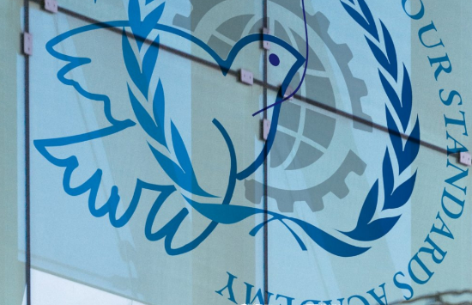
  International labour standards Academy
  13-25 May 2024: online; 27-31 May 2024: in Turin
  What? This global event provides knowledge and skills for following ILS procedures and discussions, including those on the adoption and application of ILS at the ILC.
  How? Self-guided sessions and forum discussions in the online phase; presentations followed by plenary discussions, practical activities, plenary Master Classes to exchange knowledge, ideas and experiences in the residential phase.
  How many learning hours overall? Approximately 60 hours.
  LEARN MORE AND APPLY
  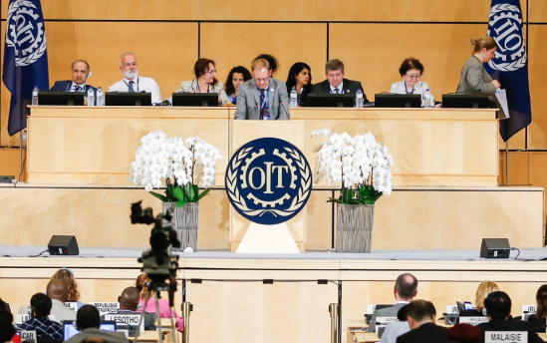
  Understanding the procedures and Constitutional obligations relating to international labour standards
  Available as from now
  What? This self-guided training provides knowledge and skills for following actively ILS procedures and complying with standards-related obligations.
  How? Self-guided sessions, with readings, unique video presentations and Internet guides, other interactive materials to work with and quizzes.
  How many learning hours overall? Approximately 30 hours.
  LEARN MORE AND APPLY

Any questions? Contact us at ils@itcilo.org
International Training Centre of the ILO
International Labour Standards, Rights at work and Gender Equality (ILSGEN)
Viale Maestri del Lavoro, 10
10127 Turin – Italy
www.itcilo.org
 |  |  | 

This Newsletter is a ILSGEN Programme's publication.
Copyright © 2023 ITCILO, all rights reserved

Sent to: s.amaiolo@itcilo.org
Unsubscribe
ITCILO, Viale Maestri del Lavoro 10, 10127 Turin, Italy

